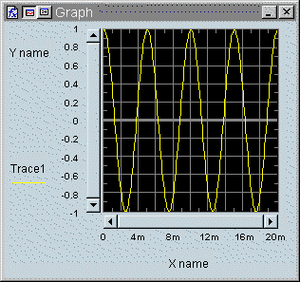
Page 1Picture description
Picture description
Picture description
Picture description
Picture description
Picture description
Picture description
Picture description
Picture description
Picture description
Picture description
Picture description
Picture description
Picture description
Picture description
Picture description
Picture description
Picture description
Picture description
Picture description
Picture description
Picture description
Picture description
Picture description
Picture description
Picture description
Picture description
Picture description
Picture description
Picture description
Picture description
Picture description
Page 2

