How to create and use a custom .dll in VEE

Introduction
One area of VEE I really had some learning issues with was how to create my own compiled function library (.dll), load it and use my functions. I am sure there are ways to create userobjects to accomplish most if not all tasks you can ever imagine. For me though, there were things I already knew how to do in C/C++ and I wanted to simply wrap my existing functions up and import them. This has been one of the most useful things I have learnt for the development of VEE applications.
For the purposes of this tutorial I will be using Visual Studio .NET to compile the files. . We will, for demonstration purposes create a .dll which will contain four functions. Each function will take two integer numbers as input and they will add, subtract, multiply and divide before returning the result. Our goal is to be able to import the .dll, drop the respective userfunction on to the VEE work area and perform these simple tasks.
First off - lets look at the listings - then we'll go through the setup of the project in Visual Studio. Incidentally, if you don't have a version of VS available you can download the express edition of Visual C here and its free.
The code then...

Math_Functions.cpp
Fairly straight forward listing of the Math_Functions.cpp file. DllMain is quite literally what it says it is. The equivalent of a standard Windows WinMain function but for .dlls. It is where the calling application can send parameters if required when it executes the code. I've never done anything with this function and have always just left as is.
Below the main function are the three math functions we are interested in. You'll notice the function definitions are a little different than usual - typically in a C function you might just have,
int add(int a, int b)
as a prototype. Instead we have these DLL exports which VEE is going to need. Typical errors if you don't have these right are 'function not loadable' when you go to execute them in VEE.

//---------------------------------------------------------------------------
// PROJECT : DLL_Demo
// FILE : Math_Functions.cpp.
// DESCRIPTION : Main .dll Source File.
// DATE START : 31 Jan 2008.
// CODERS : Shaun Harwood.
//---------------------------------------------------------------------------
//---------------------------------------------------------------------------
// INCLUDES
//---------------------------------------------------------------------------
#include "stdafx.h"
//---------------------------------------------------------------------------
// DEFINES
//---------------------------------------------------------------------------
//---------------------------------------------------------------------------
// VARIABLES
//---------------------------------------------------------------------------
//---------------------------------------------------------------------------
// PROTOTYPES
//---------------------------------------------------------------------------
//---------------------------------------------------------------------------
// FUNCTIONS
//---------------------------------------------------------------------------
//---------------------------------------------------------------------------
// DllMain();
//---------------------------------------------------------------------------
// Date created - 31 Jan 2008
// Inputs - None.
// Outputs - None.
// Basic Notes - Main DLL Entry Point.
//---------------------------------------------------------------------------
BOOL APIENTRY DllMain(HANDLE hModule, DWORD ul_reason_for_call, LPVOID lpReserved)
{
return TRUE;
}

//---------------------------------------------------------------------------
// ADD();
//---------------------------------------------------------------------------
// Date created - 31 Jan 2008
// Inputs - 1. Integer a.
// - 2. Integer b.
// Outputs - 1. Integer c.
// Basic Notes - Adds Two Integers and returns the result.
//---------------------------------------------------------------------------
DLLEXPORT short _stdcall add(short a, short b)
{
return (a + b);
}
//---------------------------------------------------------------------------
// SUB();
//---------------------------------------------------------------------------
// Date created - 31 Jan 2008
// Inputs - 1. Integer a.
// - 2. Integer b.
// Outputs - 1. Integer c.
// Basic Notes - Subtracts Two Integers and returns the result.
//---------------------------------------------------------------------------
DLLEXPORT short _stdcall sub(short a, short b)
{
return (a - b);
}
//---------------------------------------------------------------------------
// DIV();
//---------------------------------------------------------------------------
// Date created - 31 Jan 2008
// Inputs - 1. Integer a.
// - 2. Integer b.
// Outputs - 1. Integer c.
// Basic Notes - Divides Two Integers and returns the result.
//---------------------------------------------------------------------------
DLLEXPORT short _stdcall div(short a, short b)
{
return (a / b);
}

//---------------------------------------------------------------------------
// MUL();
//---------------------------------------------------------------------------
// Date created - 31 Jan 2008
// Inputs - 1. Integer a.
// - 2. Integer b.
// Outputs - 1. Integer c.
// Basic Notes - Multiplies Two Integers and returns the result.
//---------------------------------------------------------------------------
DLLEXPORT short _stdcall mul(short a, short b)
{
return (a * b);
}

Math_Functions.h
The Math_Functions.h file includes the defines for the export symbols, function prototypes and description strings which will be viewable in VEE. Nothing too special here.

//---------------------------------------------------------------------------
// PROJECT : DLL_Demo
// FILE : Math_Functions.h.
// DESCRIPTION : Main Header File.
// DATE START : 31 Jan 2008.
// CODERS : Shaun Harwood.
//---------------------------------------------------------------------------
//---------------------------------------------------------------------------
// DEFINES
//---------------------------------------------------------------------------
#define DLLEXPORT __declspec(dllexport)
#ifdef __cplusplus
extern "C" {
#endif

//---------------------------------------------------------------------------
// VEE DESCRIPTIONS
//---------------------------------------------------------------------------
DLLEXPORT char add_desc[] = "Adds Two Integer Numbers";
DLLEXPORT char sub_desc[] = "Subtracts B from A";
DLLEXPORT char div_desc[] = "Divides Integer A by Integer B Two Numbers";
DLLEXPORT char mul_desc[] = "Multiplies Two Numbers";
//---------------------------------------------------------------------------
// PROTOTYPES
//---------------------------------------------------------------------------
DLLEXPORT short _stdcall add(short a, short b);
DLLEXPORT short _stdcall sub(short a, short b);
DLLEXPORT short _stdcall div(short a, short b);
DLLEXPORT short _stdcall mul(short a, short b);
#ifdef __cplusplus
}
#endif

stdafx.h
When you create template projects in Visual Studio this file is created. Truth be told we could have had this code in Math_Functions.h. The Math_Functions.c file includes this file which in turns includes our header files.

#pragma once
//Blow away MFC
#define WIN32_LEAN_AND_MEAN
// Windows includes
#include <windows.h>
// Application Includes
#include "Math_Functions.h"

The key point is the function prototypes - if you follow the example as a guide it should work fine when you get to import the library into VEE. Now we'll set up the project in Visual Studio and compile the .dll.

Setting up the Project
OK - lets set up the project and compile the library.
First, open up Visual Studio and create a new project. In the New Project dialog box - select 'Visual C++ Project' as the type and 'Win32 Project ' as the template. In this case, name the project 'Math_Functions'. Click ok to continue. (Figure 1)
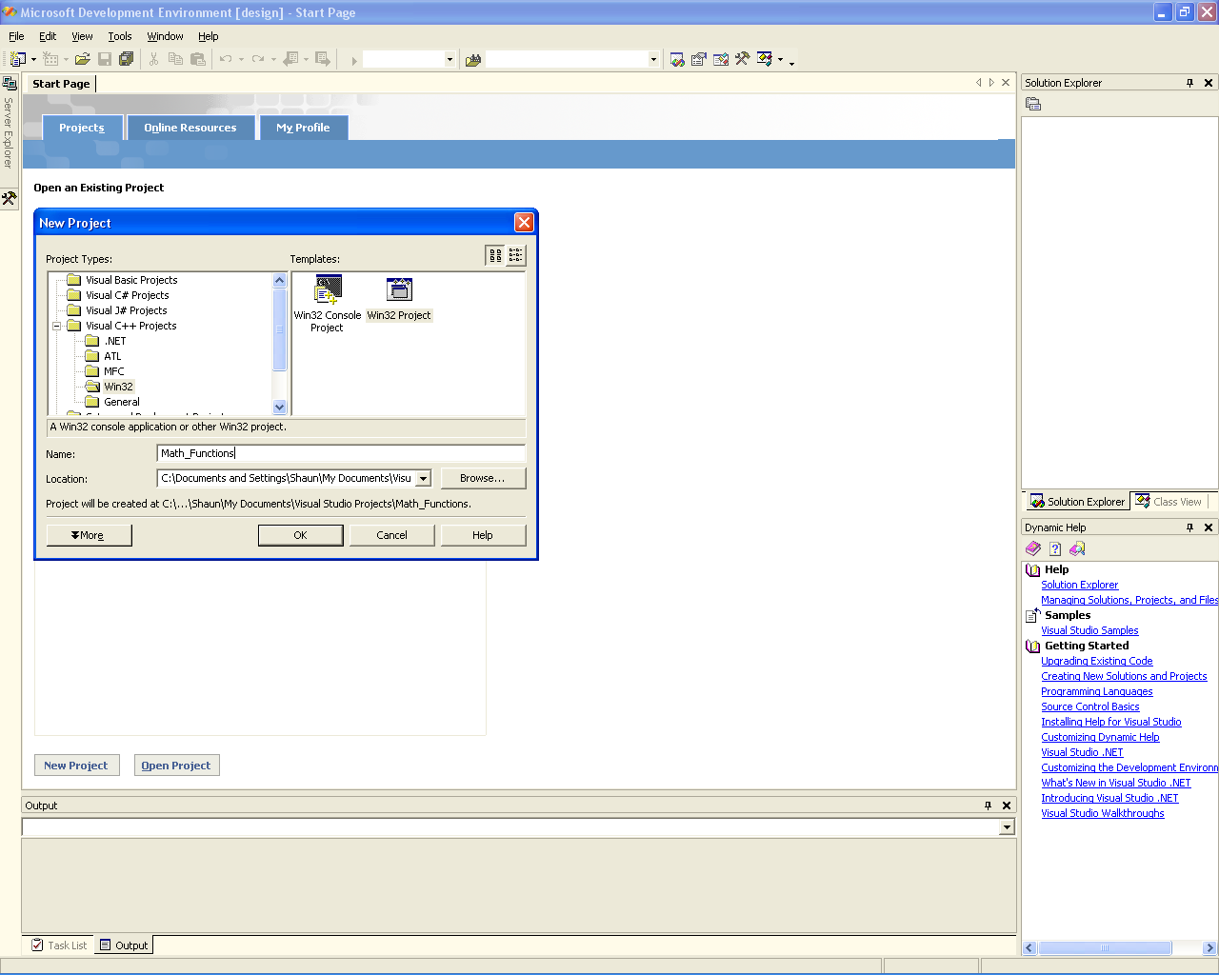
Figure 1

In the next dialog box, select the 'Application Settings' tab and make sure the options for 'DLL' and 'Empty Project' are checked. Click the finish button to set up your empty project. (Figure 2)

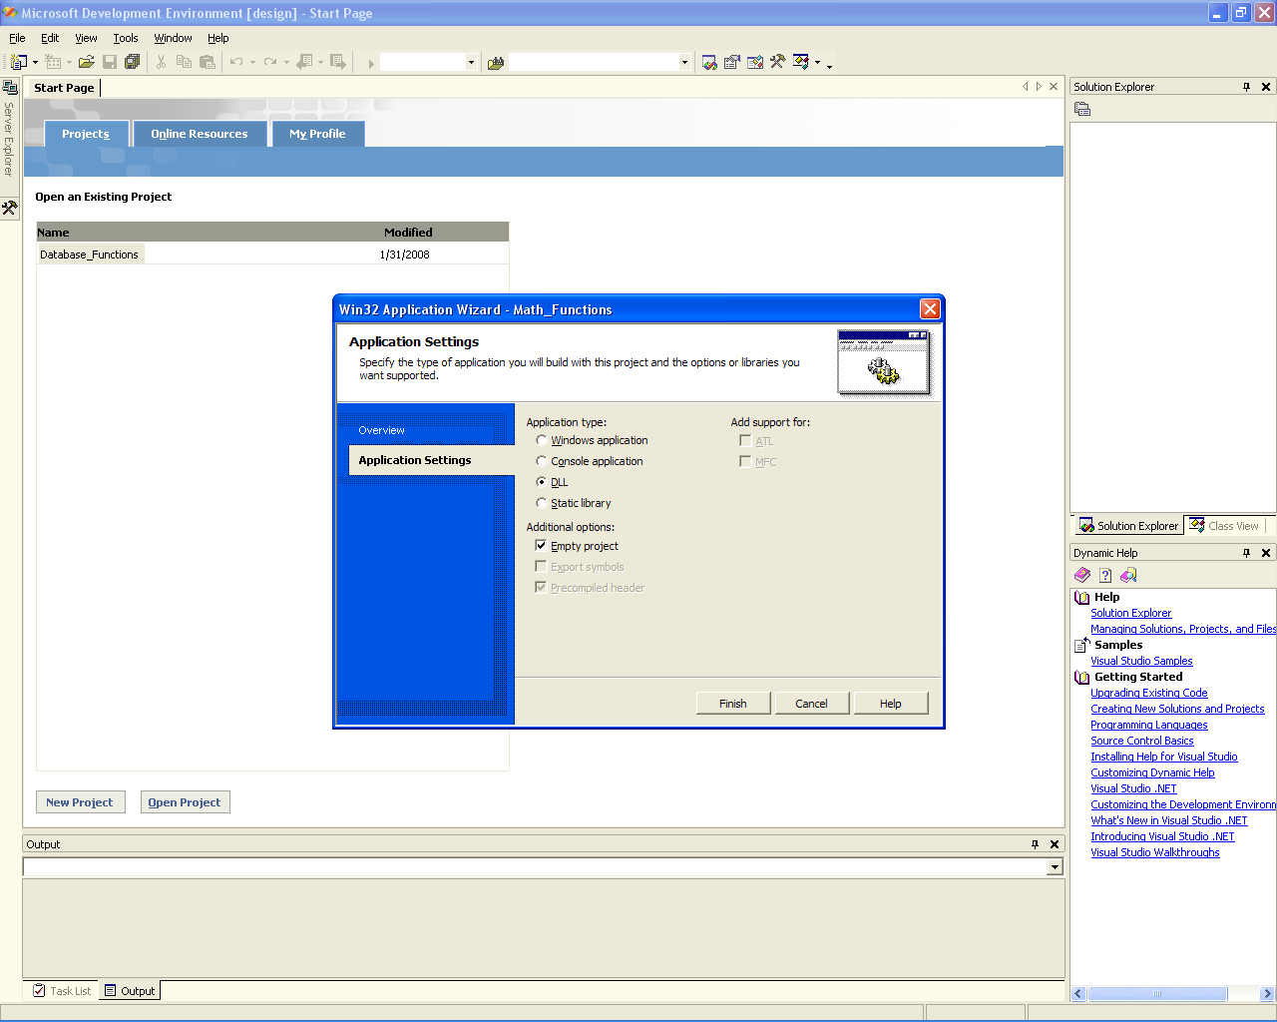
Figure 2

The empty project workspace is now in the window. (Figure 3) On the top right hand side is the solution explorer. Right click on the 'Source Files' icon to bring up the context menu and select 'Add new item'. In the 'Add new item' dialog box highlight the 'C++ File (.cpp)' option and name your new file 'Math_Functions' - click open.

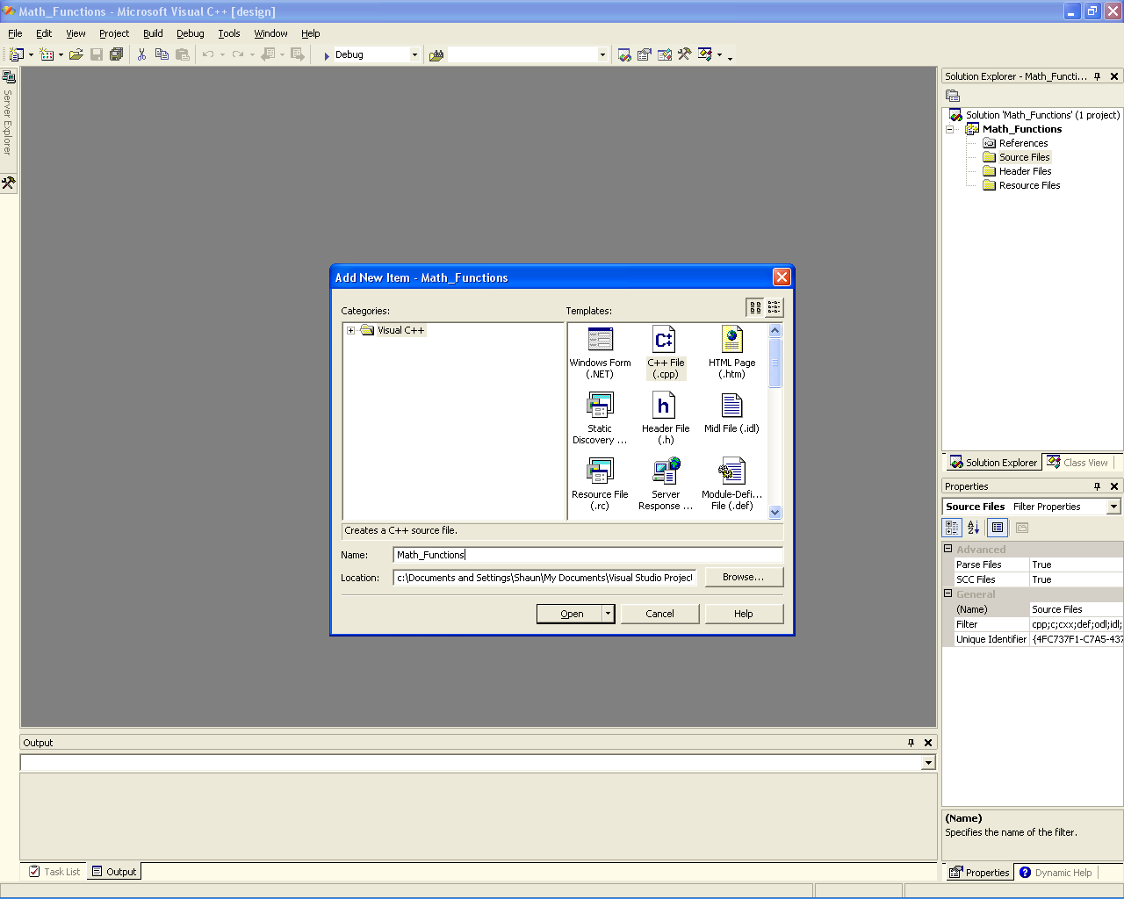
Figure 3

Repeat this step for 'Math_Functions.h' and 'stdafx.h' by right clicking on the 'header icon' in the solution explorer and highlighting 'Header File (.h)' in the dialog box. Your solution explorer should now list the three files and there should be a tab for each along the top of the workspace window.

Cut the source from the listings on this page and paste it into each of the files being careful to get the correct source in each file. Save your project.

Compiling the Library
There are two ways to compile your .dll. Release mode and Debug mode. Debug mode allows you to run a debugger during execution to trace possible errors in your code. Seeing as this is a fairly basic set of functions we will compile the .dll in Release mode as the result is smaller. (Figure 4)

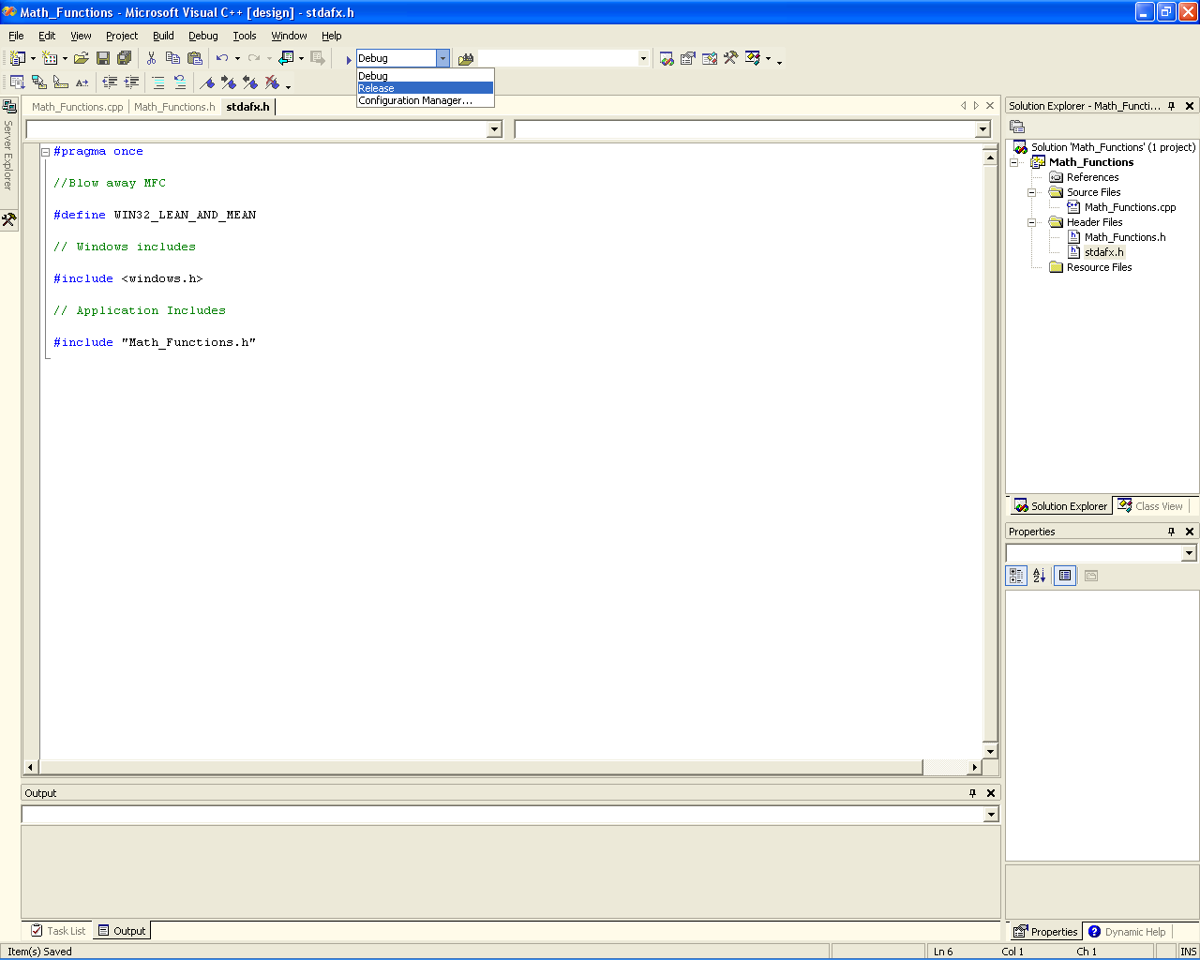
Figure 4
Select 'Release' from the drop down menu at the top of the screen - Save the project.

At this point we are good to go. From the 'Build' menu select 'Build Solution'. The project should compile without any errors and report that the build was completed successfully in the output window at the bottom of the screen.
If it did - congratulations - you just compiled your .dll - if not - go over the previous steps to see if you can identify where you may have gone wrong.
Save the project once everything is compiling ok. Your version of the compiled .dll should be in ''Your_Projects\Math_Functions\Release\'.

The VEE friendly header file
Ok - here is the key to using .dll's in VEE. You cannot use the header file from Visual Studio when you import the library into VEE. This is because VEE does not recognize all the different data-types you can possibly use and also it doesn't have a whole bunch of time for things like pre-processor directives and the like. Yes - I am sure there is a nice elegant way of doing this so you keep all the 'C' stuff in your .cpp file - but like I said - I am no expert and this works well for me. I prefer to concentrate on getting into my VEE app as soon as I can.
First lets look at the VEE friendly .h file.

V_Math_Functions.h
All we have done here is copied the function prototypes from Math_Functions.h, pasted them into a new file and removed the 'DLLEXPORT' from the beginning of each prototype. That's it.

// VEE usable prototypes.
short _stdcall add(short a, short b);
short _stdcall sub(short a, short b);
short _stdcall div(short a, short b);
short _stdcall mul(short a, short b);

Using the Functions
Create yourself a directory on your root 'C' drive called 'Test_Files' and within that directory create one called libs. Copy your 'Math_Functions.dll' and 'V_Math_Functions.h' files into the libs directory. Finally - Open up VEE.
From the Device menu, select an Import Library object and drop it on the Main workspace. Change the library type to 'Compiled Function', the name to 'Math' and point the filename and definition file boxes to your new .dll and VEE friendly header file.

Add a 'Start' button from the flow menu. Something like this,
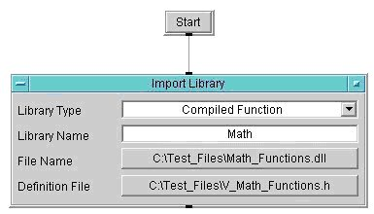

Select a Delete Library object from the Device menu and drop it on the Main workspace. Add a Start button from the Flow menu and change the name field to match your library name - in this case 'Math'. Here it is,
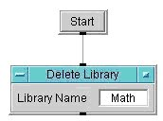

If everything is working out well you should have a screen that looks like the screenshot and by clicking the respective start buttons you should see the library appear and disappear in the program explorer on the left edge of the workspace. (Figure 5)

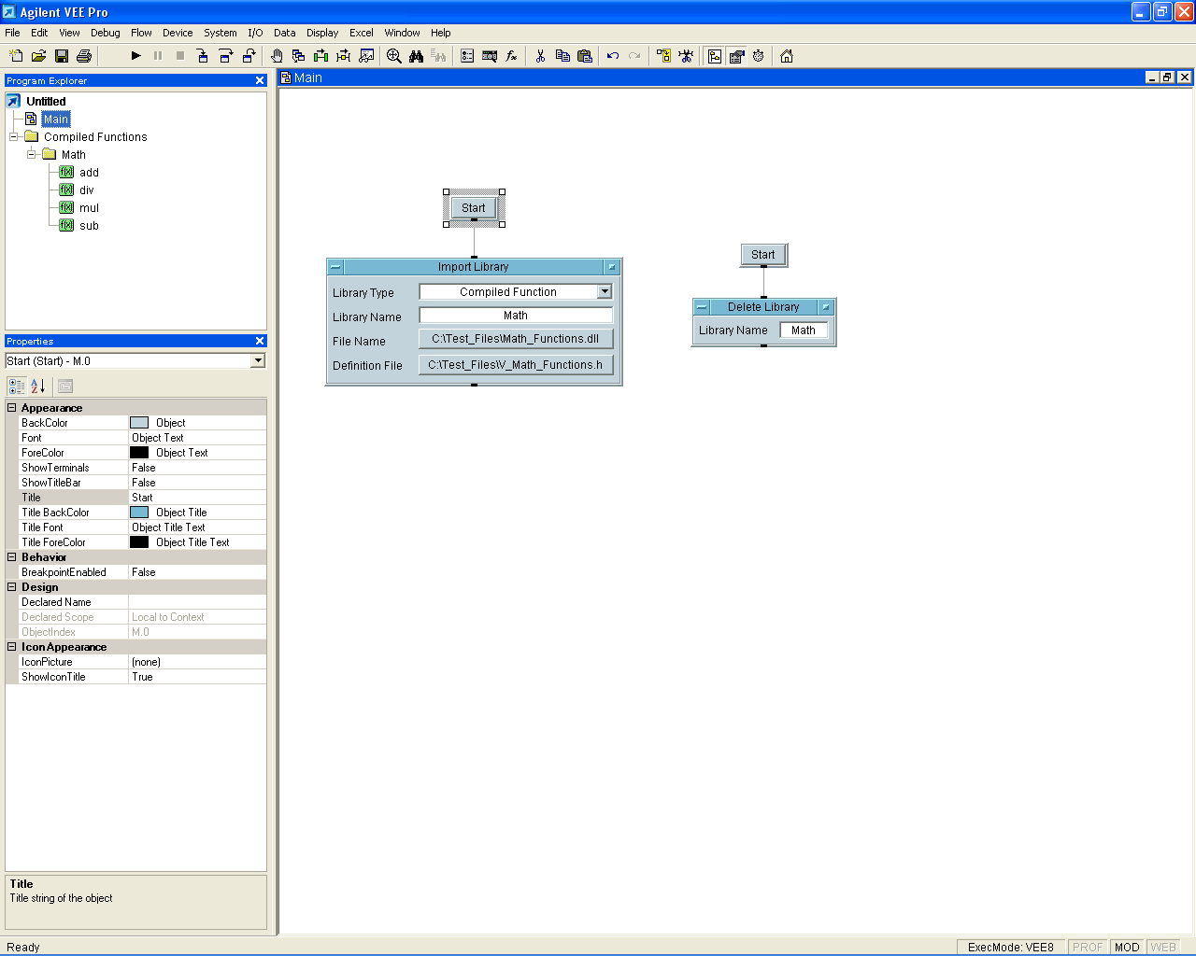
Figure 5

Click the start button to import the library and expand the folder icon in the program explorer. You should see your four userfunctions listed. Try right clicking on one of the functions to bring up the context menu and select 'Description' from the drop down menu. You should see the description we entered in the 'Math_Functions.h' file while we were building the project in Visual Studio.

Right click the 'Add' function and select Generate->Call from the menu. Drop the user function on the workspace and add a 'Start' button from the Flow menu. Add a couple of UInt8 constants from the Data menu. Data->Constant->Uint8. Add an Alphanumeric display to the output of your function. You should have something like this,
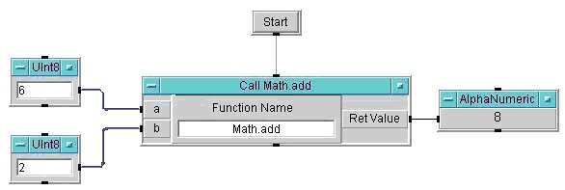

Enter some values to the inputs and hit the start button. The output should be the sum of the two inputs. A couple of minor pointers here. If the library is not imported when you go to run the function, then the function will fail. VEE will not be able to find it though the object will still be there. When we compiled the function is Visual Studio you may recall that our variable names were 'a' and 'b'. We could change them in the code, recompile the .dll, and the input and output terminals of the object could be more meaningful. Always remember to Delete the Library when you are done. Typically I create a userfunction which initializes my application and imports any libraries, and I create a Kill_App user function which tidies everything up and deletes all my libraries. Good practice I think.
Here's all the functions being used,

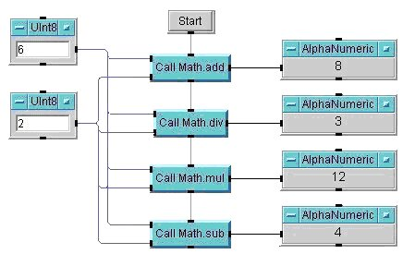

Conclusion
So we have seen how to create a basic .dll - create a VEE specific header file - import and use the functions in VEE - even add some notes to the description fields to provide our user with a little information.

