User Guide page 6

D: SYStem MENU
1: RDGS STORE > 2: SAVED RDGS > 3: ERROR > 4: TEST > 5: DISPLAY > 6: BEEP > 7: COMMA > 8: REVISION
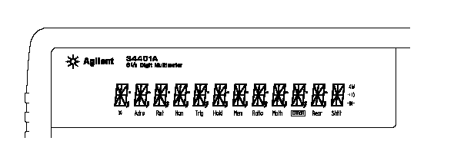

Trig  Mem | Multimeter is waiting for a single trigger or external trigger.  Turns on when reading memory is enabled.

User Guide Page 108

DATA:FEED RDG_STORE, {"CALCulate"|""}
DATA:FEED?

Programming questions for HP34401A
Questions-
- Which code makes the Trig display on the front panel?
- Which code is use to activate the SYStem MENU 1: RDGS STORE
- Which code is use to read several memory locations in the SYStem MENU 2: SAVED RDGS
- The only code I could find is on page 108 in the user guide. But I not having any great success.

These are several additional questions. The main question is pulling the data out of the internal memory.

Thanks again for your help.

