Carsten Scheuermann
Fachhochschule Heilbronn
E-Mail :

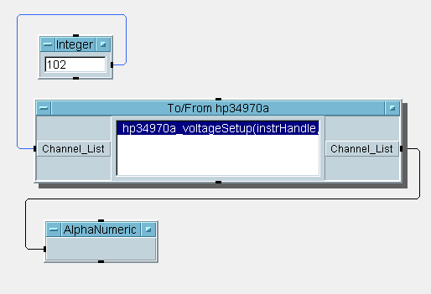In this programm from HPVEE 4.0 i become a error message. My interface card is a Natinal Instrument Gpib-PCIIA card. The HP 34970a Data Acquisition /switch unit is connected with an IEEE 488 cable.
With the HP Benchlink Data Logger the Data Acquisitions functions are correct.
The HP I/O Libraries is installed.
The plug and play driver from HP34970a for WIN95 is installed.
Have anybody a answer for my problem. My configuration in the I/O Manager is listed in the text.
Thank you for your answer.

