Agilent VEE has a lot of limitations in importing C DLL’s. However, the limitation could be bypassed using a .NET wrapper. Utilizing Interop Services with the code, the .NET object essentially encapsulates the DLL written in C, and exporting the features to be used seamlessly in Agilent VEE.

To understand more about this technology, you could browse: http://msdn.microsoft.com/en-us/magazine/cc164123.aspx

The example of wrapping a C DLL is demonstrated in wrapping the FFTW library by Matteo Frigo (http://www.fftw.org). For the example listed here, the libfftw3f-3.dll (Real32 Windows 32-bit version FFTW 3.2.2 compilation) is used. The DLL could be downloaded from the Windows Download section.

As a simple example, definitions like the following :

#define FFTW_FORWARD (-1)
#define FFTW_BACKWARD (+1)

Could be enumerated and wrapped such as this for VEE:

public enum fftw_direction : int
{
/// <summary>
/// Computes a regular DFT
/// </summary>
Forward=-1,
/// <summary>
/// Computes the inverse DFT
/// </summary>
Backward=1
}

This actually allows a clearer and easier usage when importing the .NET assembly and using the .NET object in Agilent VEE in the drop down selection and the Operation display:
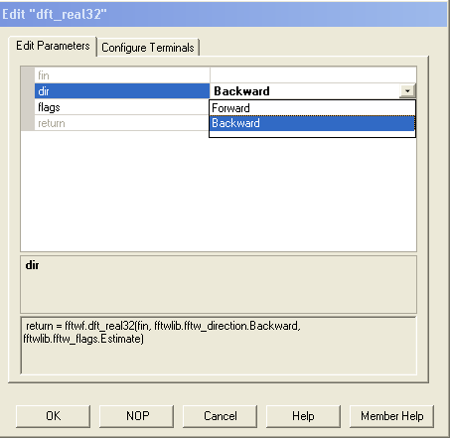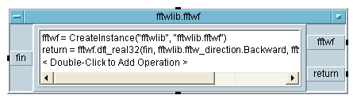
Certain complicated definitions unsupported in VEE such as bit-shift operators below could be simplified into easy understandable types:
/* documented flags */
#define FFTW_MEASURE (0U)
#define FFTW_DESTROY_INPUT (1U << 0)
#define FFTW_UNALIGNED (1U << 1)
#define FFTW_CONSERVE_MEMORY (1U << 2)
#define FFTW_EXHAUSTIVE (1U << 3) /* NO_EXHAUSTIVE is default */
#define FFTW_PRESERVE_INPUT (1U << 4) /* cancels FFTW_DESTROY_INPUT */
#define FFTW_PATIENT (1U << 5) /* IMPATIENT is default */
#define FFTW_ESTIMATE (1U << 6)

Simplified into:
public enum fftw_flags : uint
{
Measure=0,
DestroyInput=1,
Unaligned=2,
ConserveMemory=4,
Exhaustive=8,
PreserveInput=16,
Patient=32,
Estimate=64
}

The most difficult aspect in wrapping a C-based DLL is Data Marshalling. Assigning different or incompatible data types and sizes would result in an error in “accessing protected memory” when importing and running the .NET object in VEE.
Data types and size considerations are especially important and may be frustrating to those who are unfamiliar with bytes, bits, pointers and addresses.

Agilent VEE when importing compiled functions, could not support pointers and obtain data from pointers.
As an example, we would include the dft_1d function from the fftw library.

In the fftw3.h header file, the dft_1d function is declared as:
FFTW_EXTERN X(plan) X(plan_dft_1d)(int n, C *in, C *out, int sign, unsigned flags);

It might not make any sense, unless you read the other portions of the header file below:

#if defined(FFTW_DLL) && (defined(_WIN32) || defined(__WIN32__))
/* annoying Windows syntax for shared-library declarations */
# if defined(COMPILING_FFTW) /* defined in api.h when compiling FFTW */
# define FFTW_EXTERN extern __declspec(dllexport)
# else /* user is calling FFTW; import symbol */
# define FFTW_EXTERN extern __declspec(dllimport)
# endif
#else
# define FFTW_EXTERN extern
#endif

This header is actually included for the compiler to identify whether the function is for export or import, and to handle the Windows syntax and non-Windows syntax. Hence FFTW_EXTERN simply means extern in C sense.
The X thing is actually a pointer to a structure as shown in another statement in the header file:
typedef struct X(plan_s) *X(plan);

We get the prefix as well as the header from the second order macros in the header file, in this case the entry point for the specific function in the example would be fftwf_plan_dft_1d. In order to understand a header file properly, normally the manual or user instructions should be studied.:
#define FFTW_DEFINE_API(X, R, C)
#define FFTW_CONCAT(prefix, name) prefix ## name
#define FFTW_MANGLE_FLOAT(name) FFTW_CONCAT(fftwf_, name)
FFTW_DEFINE_API(FFTW_MANGLE_FLOAT, float, fftwf_complex)

How do we wrap it up in .NET? Simple, just use the P/Invoke method of DLLImport (it is important that you have read the P/Invoke article on http://msdn.microsoft.com/en-us/magazine/cc164123.aspx, if not please read it now). The following code would actually import that function in the C DLL and wrap it nicely for use for other programs such as Agilent VEE :
[DllImport("libfftw3f-3.dll",
EntryPoint = "fftwf_plan_dft_1d",
ExactSpelling = true)]
public static extern IntPtr dft_1d(int n, IntPtr input, IntPtr output,
fftw_direction direction, fftw_flags flags);
The wrapping isn’t completed yet if the pointers have not been removed, as VEE does not support IntPtr pointer actions. So in the example we declare a type that VEE supports, the which is the float(real32) array! The declaration would be like this:
public float[] dft_real32(float[] fin,fftw_direction dir,fftw_flags flags)
{
The fftw_direction and fftw_flags have been enumerated earlier in the earlier sections of this article. What this function would do, is it would actually accept a float/real32 array as an input as well as the two configuration parameters, execute the dft_1d function and then return the output data!
So we declare two pointers to unmanaged arrays because the function only accepts C* data-type, which is float* because of the macros.
//pointers to unmanaged arrays
IntPtr pin, pout;
Then we declare a pointer to handle the plan structure data-type.
IntPtr fplan1;
After that we declare two Garbage Collector handles. Memory in .NET assemblies are handled by the Garbage Collector, if there are no handles, the Garbage Collector would actually wipe out and free your data before your program has even finished running. This is to prevent weird errors from happening in your program.
//handles to managed arrays, keeps them pinned in memory
GCHandle hin, hout;
The length of the input and output has to be determined before passing as unmanaged into the C DLL.
int n = fin.Length;
float[] fout = new float[n];
An n*4 size is allocated for the unmanaged arrays, because n is the size of real32 which is 4 bytes (1 byte is 8 bits).
//create two unmanaged arrays
pin = fftwf.malloc(n *4);
pout = fftwf.malloc(n *4 );
Then we pin the arrays to handles so that the dreaded Garbage Collector doesn’t collect them.
hin = GCHandle.Alloc(fin, GCHandleType.Pinned);
hout = GCHandle.Alloc(fout, GCHandleType.Pinned);
Then we initialize the unmanaged arrays that we have memory allocated just now by using the Marshal Copy method. This also copies the input data to the input array, which is ‘pin’.
//copy managed arrays to unmanaged arrays
Marshal.Copy(fin, 0, pin, n );
Marshal.Copy(fout, 0, pout, n);

The core function of this is to set the plan and execute it. The loop of 10,000 times is related to level of refinement for the accuracy of the Discrete Fourier Transform.
fplan1 = fftwf.dft_1d(n/2, pin, pout, dir, flags);

for (int i = 0; i < 10000; i++)
fftwf.execute(fplan1);

After the data has been refined we copy out the data using the Marshal Copy method too. Note that the order and parameters are different, as this is a copy out method which is different from the copy in method earlier.
Marshal.Copy(pout, fout,0, n);
Since the operation has been completed, the memory would be freed, including the handles so that Garbage Collector would dump them.
//Freeing memory

fftwf.free(pin);
fftwf.free(pout);

fftwf.destroy_plan(fplan1);

hin.Free();
hout.Free();

Last but not least, return the final output back to VEE.
return fout;
Compile the .NET DLL, copy the new DLL, together with the original unwrapped C DLL into the folder which is hosting your VEE application (the header .h file is unnecessary in this case) and then include in VEE via the .NET Assembly References, instead of the Import Library function:
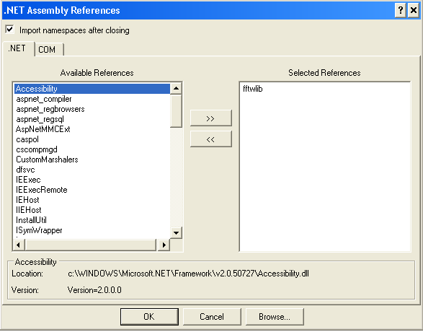
Then use the .NET operation builder and then drop the fftw library, first add the CreateInstance operation first as this is to create the .NET object from the class, then, add in the dft_real32 function that we defined earlier in the .NET DLL as an operation. Voila! The C DLL could be used:

