**Here is a standard response to our customers’ queries on VEE Pro’s future**

Keysight Technologies is committed to ensure that our VEE customers have continued Microsoft Windows OS support and eventually a transition path to future Keysight software solutions.

* Today’s VEE version 9.32 supports Windows XP, 7 and 8
* There will be a new version of VEE that supports Windows 10 by Q3 2017. (*Beyond product improvement, there will be no additional functionality planned for VEE. This new VEE version will support Microsoft .NET framework up to version 4.6).*

Attached box below is Microsoft’s Windows Product lifecycle fact sheet for your reference.

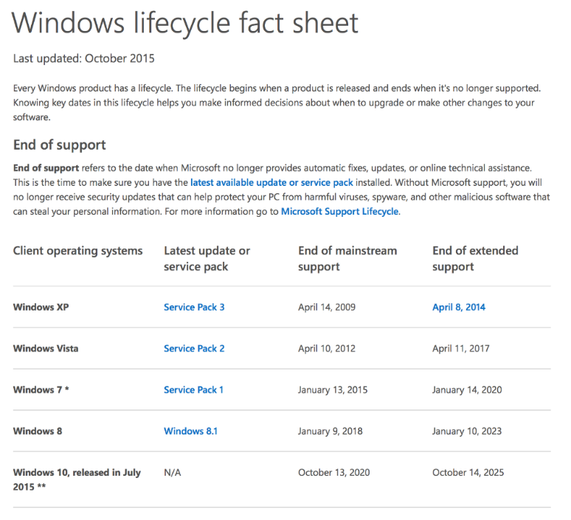

Alternatively, tasks done in VEE can be accomplished in other recommended ways, such as:

* For full system control, Keysight supports a wide array of development environments with instrument drivers, programming examples and connectivity via [*IO Libraries*](http://www.keysight.com/en/pd-1985909/io-libraries-suite?nid=-33330.977662.00&cc=MY&lc=eng).
* Instrument command reference and linear sequencing is accomplished quickly with no cost using the [*Keysight Command Expert*](http://www.keysight.com/en/pd-2036130/command-expert?nid=-32987.992473.00&cc=MY&lc=eng).
* Simplified instrument control and measurement sequencing without user instrument programming is available from the GUI driven [*BenchVue*](http://www.keysight.com/find/benchvue) platform. (Please go into www.keysight.com or simply click on the BenchVue hyperlink above to see the product families it is currently supporting).

New and powerful instrument control solutions continue to come from Keysight. For future measurement applications Keysight strongly recommends customers:

* Leverage Keysight technology within Visual Studio when writing new custom programs
* Use BenchVue and the Test Flow Application to accomplish tasks without programming