AutoCAD Training Agenda

Morning Session - November 2, 2001

8:30 am - 9:00 am Set-up, Introductions

9:00 am - 9:50 am General Overview
Screen

Menu
Toolbars
Command Line
<Play Time>

10:00 am - 10:50 am Open File
Directory Structure
Basic Draw
Basic Edit
<Play Time>

10:50 am - 11:00 am Break Time

11:00 am - 12:00 pm Print/Plot File
Paper Space/Model Space
<Play Time>

12:00 pm - 1:00 pm Lunch Break

1:00 pm - 1:45 pm Drawing Entities
Lines, Polylines

Construction (Rays, Lines)

Modifying Entities

1:45 pm - 2:15 pm Student Time

2:15 pm - 2:30 pm Break Time

2:30 pm - 3:30 pm External Data
Xreferences
Blocks
Layers
Plot/Paper Space/Model Space Review

3:30 pm - 4:30 pm Student Time

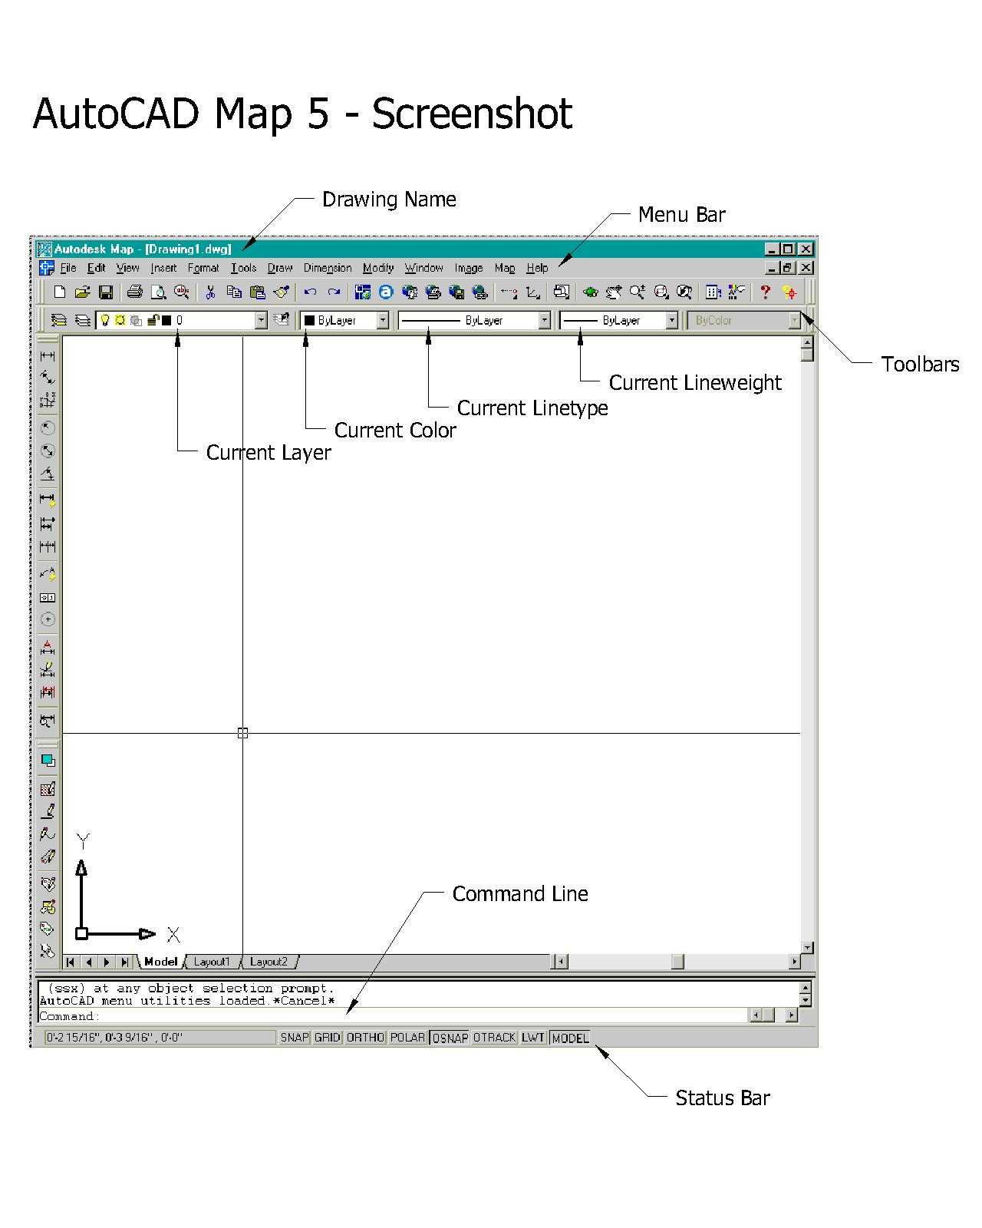

AutoCAD Training Agenda

Morning Session - November 2, 2001

General Discussion:

There are many ways to execute commands
- Menu, Toolbars (docked/floating)
- Command Line
- F Keys
- Hot Keys
- Rt. Mouse
- Status Bar
- Menu Bars that display > (arrow) hold and another menu will appear (MS Windows standard)
- Menu Bars that display … (3 dots) will bring up a dialog box
- Toolbars with > (arrow) denotes dropdown toolbar
- Underlined letters in menu or dialog boxes; use that letter as an abbreviation for the entire command word
- Information in < > mean that is the default value and usually a return will activate the default command
- Read the Command Line – AutoCAD is constantly talking to you

F Keys:

F1 - Help
F2 - Text Window
F3 - Osnap Settings (Right click OSNAP button on status bar, Pick Settings)
F4 - ***Tablet (not used)
F5 - ***Isoplane (Toggles isoplane: top, right, left)
F6 - Coords On/Off (displays pointer coordinate location: left side status bar)
F7 - Grid (Toggle On/Off)
F8 - Ortho (Toggle On/Off)
F9 - Snap (Toggle On/Off)
F10 - Polar Tracking (Toggle On/Off)
F11 - Object Snap Tracking (Toggle On/Off)
F12 - ***(not used)

AutoCAD Training Agenda

Morning Session - November 2, 2001

Most Frequently Used Menu Commands:

File -> New…
Open…
Close
Save
Save As…
Plot…
Exit
Edit -> Undo
Cut Ctrl+X
Copy Ctrl+C
Paste Ctrl+V
View -> Regen
Zoom >
Pan >
Toolbars…
Insert -> Block…
External Reference…
Layout >
Format -> Layer…
Color…
Linetype…
Text Style…
Tools -> Inquiry > Distance/Area/List
Properties… Ctrl+1
Drafting Settings…
Options…
Draw -> Line
Polyline
Polygon
Rectangle
Hatch…
Text > Multi Line Text…/Single Line Text
Dimension -> Linear
Angular
Leader
Tolerance…
Modify -> Properties… (2nd occurrence in menus)

Match Properties
Object >
Erase
Copy
Mirror (do not use, creates drawing integrity problems)
Offset
Array…
Move
Rotate
Scale
Stretch

Trim
Extend
Chamfer
Fillet
Explode
Window -> Close…
Close All…
1. Drawing1.dwg…etc.
Image -> Not commonly used.
Map -> For Advanced CAD users…
Help -> Autodesk Map Help F1
Today
What’s New
Tutorials
AutoCAD Learning Assistance
AutoCAD Support Assistance

Toolbar Discussion: See handout

AutoCAD Training Agenda

Morning Session - November 2, 2001

Command Aliases “HOT KEYS”
Hot Keys denoted in Italics are not standard AutoCAD hot keys.
Minus symbol preceded hot keys activate command line response, not dialog box interface.

KEY COMMAND DESCRIPTION

A arc for drawing arcs
AA area gives area of boundary
AP appload loads other applications to the current session of ACAD
AR array arrays entities, either polar or x,y
AT ddatte used to edit and define block attributes
-AT attdef change attribute definition
BC blkcount gives total # of blocks based on name
BL blklayer routine that changes furniture blocks to correct layer
BM blipmode toggles blipmode on/off
BP boundary creates a closed polyline (once the bpoly command)
BS blockshow allows block name to be entered and displays image
BP bpoly boundary command, makes closed polyline

C copy for copying objects
CH ddchprop changes layer, linetype, & color of multiple entities

CI circle for drawing circles

CR copyrot copy and rotate entities
D dist displays distance between two user defined points
DA ddatte modifies attribute in block
E erase erases any entity
ED ddedit edits text strings one at a time
EX extend extends lines to a user defined edge
F fillet connects the ends of two lines

GS greensheet runs the greensheet command to count and value blocks

H dialog box Herman Miller + fur symbols
I ddinsert insert blocks
L line starts the "line" command
LI list lists entity data of selected objects
LA ddlmodes layer control dialogue box
LC laychg pick object on layer you want next object to go on
LE leader text leader, arrow point first, then line to text
LF layfrz pick entity on layer that you want to freeze
LS layset sets current layer by picking object on a specified layer
LO layoff turns layer off by selecting an entity
LL laylock locks layer by picking object on that layer
LU unlock unlocks layer by picking object on that layer

AutoCAD Training Agenda

Morning Session - November 2, 2001

Command Aliases “HOT KEYS”
Hot Keys denoted in Italics are not standard AutoCAD hot keys.
Minus symbol preceded hot keys activate command line response, not dialog box interface.

KEY COMMAND DESCRIPTION

MI mirror mirrors any entity
MO ddmodify will modify and change any entity (very powerful)
MR moverot move and rotate entities
MS modelspace standard drawing environment

MT mtext allows paragraph of text to be entered
O offset offsets entity to a user defined distance
P pan pans display from a point to a point (dynamic)
-P pan pans display from a point to a point (command line)
PL polyline starts polyline command
PS paperspace for plotting
R rotate rotates entities

RC rectang draws a rectangle from two corner points
RD redraw redraws the current screen
RG regen regenerates the entire screen
S stretch stretches an entity
SC scale scales any entity
SR script runs a select script file (macro)
SS sstretch runs a stretch command where entity selection is improved
ST style create/modify text styles
T dtext dynamic text, displays on screen as you type it
TR trim will trim a line using another line a cutting edge
W wblock creates a wblocked drawing from existing data
X explode explodes blocks into elements
XL xline construction lines ( display only , will not plot )
Z zoom zoom window

AutoCAD Training Agenda

Morning Session - November 2, 2001

AUTOCAD PLOT SHEET

Paper Size: Printable Area:

ANSI A 8.5" X 11" 7.16" X 10.6”

ANSI B 11" X 17" 9.66" X 16.60"

ANSI C 18" X 24 15.66" X 21.60"

ANSI D 24" X 36" 20.66" X 33.60"

ANSI F 28” X 40” 27.60” X 38.66”

ANSI E 36" X 48" 33.60" X 42.66"

Model Space Plotting:

Scale Plot Inch=Dwg Units Plot Inch=Dwg Units Zoom Factor
[Arch] [AutoCAD Plot Box] [Paper Space]
1 1" = 1' 1 = 12 1/12xp
3/4 3/4" = 1' 1 = 18 1/18xp
1/2 1/2" = 1' 1 = 24 1/24xp
1/4 1/4" = 1' 1 = 48 1/48xp
3/16 3/16" = 1' 1 = 64 1/64xp
1/8 1/8" = 1' 1 = 96 1/96xp
3/32 3/32" = 1' 1 = 128 1/128xp
1/16 1/16" = 1' 1 = 192 1/192xp

Paper Space Plotting:

Plot Paper Space layouts with scale set to 1 : 1
(View port scale dictates output plot scale).
Note: In Paper Space each view port, within the layout, can have a separate view port scale set.

Plot Paper Space layouts “Scale to Fit”, if scale is not an issue.

Lunch Break: 12:00pm – 1:00pm, Please be on time.

AutoCAD Training Agenda

Afternoon Session – November 2, 2001

Entities – are objects like Lines, Circles, Arcs, Rectangles, Text, blocks, External References, etc. Entities have properties that define how the entity looks and behaves.

Basic Objects (DRAW Commands):

- Line

Initiate the Line command
Pick a point to start (use snaps or give an xy coord for specific placement)
Place cursor in direction of line and
pick end point (use snaps and/or Ortho controls) or
enter distance (i.e. 20’) or
enter relative point and angle (i.e. @5’<45)

- Polyline (aka Pline)

Created the same way as line command but the segments are joined as one entity. Can include arcs, have a width factor, and close to form an area.

Polygon (square, triangle, octagon…..)

Many sided object with sides of equal length
Initiate Polygon command
Enter number of sides (1-1024 sides)
Pick center point
Select (I)nscribed or (C)ircumscribed. Inscribed means the whole polygon will fit within the outer boundary of the second pick versus tangent to a circle.

- Circle

Initiate Circle command
Select method of circle: 3P (using 3 points); 2P (using 2 points); TTR (tangent); <Center Point> Center is most common

- Arc

Initiate Arc command
There are many choices to this command with multiple points and starting/stopping points. Please read and respond as needed. Further info can be obtained through the online help or asking a CAD operator.

AutoCAD Training Agenda

Afternoon Session – November 2, 2001

Other Lines or Construction Tools (more DRAW commands):

- Multiline – (aka Mline) a multiple line segment with a defined offset (scale). Use MLedit command to modify intersections.

- Ray - a continuous line beginning at a selected point and extending infinitely
- Construction Line – a continuous line created by selecting the mid-point and going indefinitely in both directions

The Zoom Extents command ignores infinite Rays and Construction Lines.

Modifying Elements (MODIFY commands):

- Offset - creates a duplicate entity at a defined distance.

- Array – Multiple offset of an object horizontally and/or vertically.

- Erase – gets rid of an object (may not get rid of all properties or definitions)
- Copy – copy one or multiple object(s) using a base point as a pickup point
- Move – move an object(s) position from one place to another using a base point
- Rotate – take an object and alter its orientation around a base point
- Scale – make an object larger or smaller based on a base point and scale factor or reference
- Trim – select the cutting object and then select the object to be cut
- Extend – select the object to extend to then select the object to extend

- Break – breaks a line/polyline into two separate lines/polylines.

- Fillet – make two objects extend and meet at their apparent intersection
- Properties – changes the ‘description’ of an object

AutoCAD Training Agenda

Afternoon Session – November 2, 2001

External Data (INSERT Commands)

Two major approaches to sharing data with other CAD drawings are Blocks and External References (Xref).

The characteristics of a Block are:

‘inserted’ into a drawing

static object (they do not change as the original changes)

permanently part of the new drawing
- can have attributes that are modifiable
- position is typically placed manually

Block Attributes – Blocks that have special attributes can be modified. (Modify; Object; Attribute or use the AT hotkeys). Select the object and type in the changes.
The characteristics of an Xref are:

visual ‘links’ to other CAD drawings

dynamic object – if original drawing changes data is refreshed when reopened
- temporarily part of the new drawing (only link is saved reducing file size)
- supports the draw it once and use it many concept
- no modifiable data
- position is almost always inserted at 0,0 (zero X, zeroY coordinate)

Xref Attach vs Overlay – An Attached Xref will be present/visible if the current drawing is referenced, an overlayed drawing will not.

Attached: Drawing A ←----- Drawing B ←-------- Drawing C
Overlay: Drawing A ←----- Drawing B
Xrefs should never be Erased !!! If you will no longer need the Xref, detach the drawing through the Xref manager.

AutoCAD Training Agenda

Afternoon Session – November 2, 2001

Layers

Layers are used to control groups of data. Common controls for layers are:

- Name - <Description> Unique alpha/numeric identifier for the layer.

- On/Off - <Light Bulb> Makes objects on layer visible or not. It is not recommended to use this function – use the Freeze/Thaw option!

- Freeze/Thaw - <Sun/Snowflake> Makes objects on layer visible or not and removes them from the drawing database. This will make help make routines faster as it does not have to search through as much data.

- Freeze/Thaw Viewports - <Sun/Snowflake/Box> This is only available if you use viewports and/or paperspace

- Lock/Unlock - <Padlock> This controls the selection ability of an object. The data is visible but it cannot be selected or modified.

- Color <color box> All objects on this layer will be displayed the Layer Color unless the objects color has been set.

- Linetype - <line example> All objects (lines, plines, circles, etc.) will be displayed using the Layer Linetype unless the objects linetype has been set.

- Lineweight - <line thickness> Default line weight is plotted unless re-assigned here.

- Plot Style - <alternate pen assignment> Default color/pen is plotted unless re-assigned. Then the layer plots with an assigned color/pen independent of the display/screen color.

- Plot - <layer active/inactive plot> Plotting individual layers may be turned on or off.

Characteristics of Layers:

A ‘current’ layer is selected (see menu bar for current layer info). Objects that are inserted or xref'd will go on the ‘current’ or active layer.

Create a new layer X-______ for xreferences. This will allow the entire xref to be frozen or thawed in one step.

Xref Layers are depicted by the Drawing Name, a vertical bar, then the layer name. [For example, R1U-BLD|b-doors]. If you freeze this layer, all data on this layer will become invisible.

Layer Names can be Alpha (A-Z) or Numeric (0-9) and include a dash (-) or an underscore (_). Our layer naming convention is:

AAA-BBBBBBBB

Where AAA denotes the discipline and BBBB is the description

Layer Translator:

From the menu bar: Tools -> CAD Standards -> Layer Translator

A drawing translation tool for converting multiple layer names to a new set of standard layer names. The translator is based on a 1:1 or many to 1 layer conversion process.

Notes:

