Installing VEE 9.32 in Windows 10

Disclaimer : Windows 10 is not officially supported by Keysight VEE Pro 9.32.

**Pre-requisite**

1. Keysight IO Libraries Suite 16.3.16603.3 or 2017 update 1

(This is only needed when you communicate with instruments using Keysight VEE)

1. Microsoft .NET Framework 3.5 SP1

*Microsoft.NET Framework 3.5 SP1 is not included in Windows 8/10. The Keysight VEE installation package will prompt you to download and install lMicrosoft.NET Framework 3.5 SP1 from the IO Libraries Suite 2017 update 1*

**Steps to install VEE 9.32 in windows 10**

1. Install IO Libraries version 2017 Update 1 from the link below

<http://www.keysight.com/find/IOLIB>

Restart computer if necessary.

1. Install Microsoft Office 2016 or below, Microsoft Office 365 was not supported in VEE 9.32
2. Download and install VEE 9.32 from the link below

<http://www.keysight.com/find/vee_download>

**Appendix – If VEE does not work after install IO libraries 2017 update 1**

In case of the installation of VEE fails due to .NET 3.5 framework, please follow the steps below

1. Close all running programs.
2. Login as administrator.
3. Go to Control Panel, view by Large Icons, then click on Programs and Features.
4. Select “Turn Windows features on or off” and you will see screen below.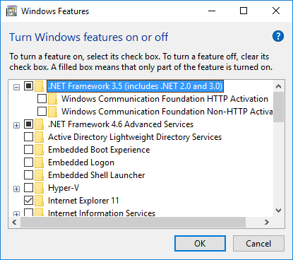

Uncheck Microsoft .NET Framework 3.5.1, this will un-install .NET Framework 3.5.1.

Restart PC.   
(NOTE: This step need to be performed again even though if it has been done earlier)

1. Go to “Turn Windows features on or off” in step 2 again.
2. Check Microsoft .NET Framework 3.5.1 to install it again.
3. Leave it uncheck for both HTTP/Non-HTTP item. Restart PC.

Remark: Vee Pro 9.32 should be able to run in Windows 10 after performing the steps above.

1. If VEE is still not able to launch, please right click VEE => “Run as administrator” and see whether it work, if it still does not work, go to step (9)
2. Please see readme file from VEE install directory (Readme.htm) Error System.UnauthorizedAccessException when launch VEE perform steps from 2(a) - 2 (d)

Running VEE Pro 9.32 in Win 10

|  |  |  |
| --- | --- | --- |
| Features | Works in Windows 10 | Does not work in Windows 10 |
| Microsoft Office | Microsoft Office 2016 and below | Microsoft Office 365 |
| Active X Controls or Windows Forms Contols | 32-bit | 16-bit or the Error* is encountered |
| .NET Libraries and Drivers | 32-bit and .NET 2.0 to 3.5 | 64-bit or .NET 4.0 and above |
| IVI-COM Drivers | 32-bit and .NET 2.0 to 3.5 | 64-bit or .NET 4.0 and above |
| Mathworks ® Matlab | R2015b or below (32-bit only) | R2016a or 64-bit |
| To/From Socket or Callable VEE Server (veesm.exe) | If Firewall and Security application is properly configured | **Socket Error encountered |
| Any imported components or DLL’s | 32-bit | *if the Error is encountered |

* If the following error is encountered, that means the library or imported component is not supported in Windows 10. The various reasons for this could range from discontinued dependencies e.g. Windows Media Center, certain ActiveX controls, access to Conventional memory or even 16-bit memory addressing.

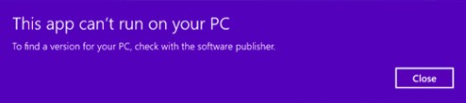

If you still utilize the 32-bit version of Windows 10, there is a workaround that could be attempted that would solve certain issues by reinstalling Windows Virtual Dos Machine (NTVDM) , it is not installed by default on Windows 10 (<https://answers.microsoft.com/en-us/insider/forum/insider_wintp-insider_perf/what-is-ntvdm-and-why-would-i-need-it/5315217b-ebcf-4548-af97-41a2cf6d1738> ) :

To do so, press **Windows key + R** then **type:** optionalfeatures.exe then hit Enter. Expand Legacy Components then **uncheck** off NTVDM and click OK.

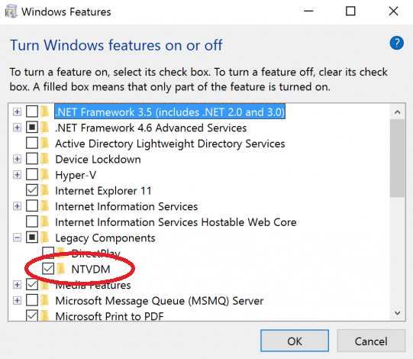

After that, press **Windows key + X** then click Command Prompt (Admin.) At the command prompt, type the following command:

FONDUE.exe /enable-feature:NTVDM

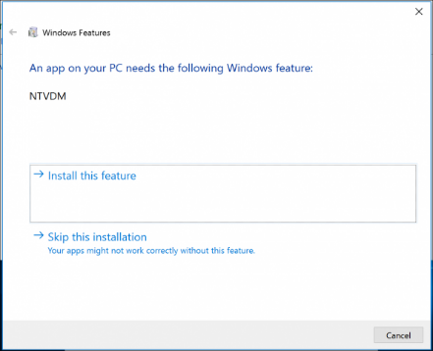

The add feature wizard for NTVDM will launch. Click Install this feature to complete the installation. Then restart your computer and try to run VEE again.

Unfortunately for 64-bit of Windows 10, NTVDM is not provided at all.

** if a socket 10013 is encountered, it might due to a more stringent Windows firewall blocking the port used. You could configure it at: <https://support.microsoft.com/en-us/help/4028544/windows-turn-windows-firewall-on-or-off> and configure your own firewall software.

If all of the workaround also fails, running a third party virtual machine software hosting earlier versions of Windows will enable VEE pro to run in Windows 10.