Error report : connection VEE and Multimeter 34401A
13 july 2010

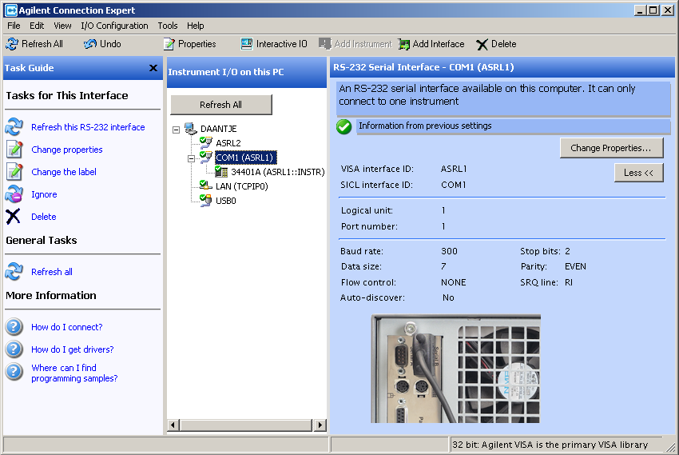

With the Agilent connection expert the RS-232 was programmed as indicated above.

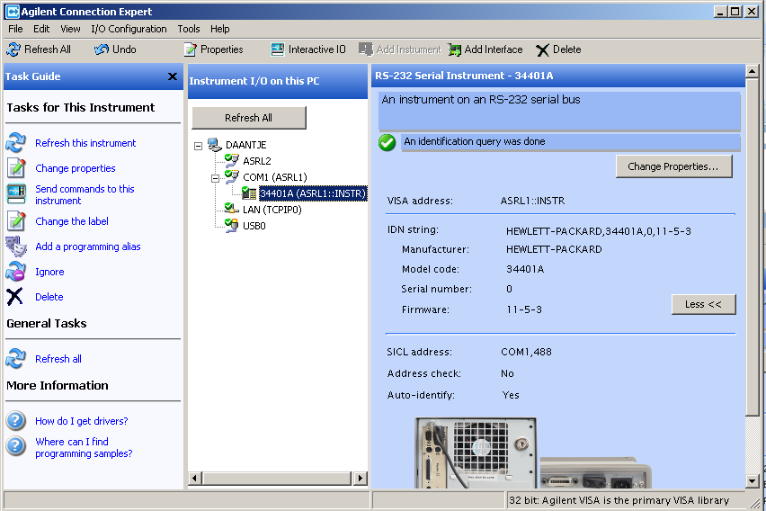

The Multimeter 34401A has been found

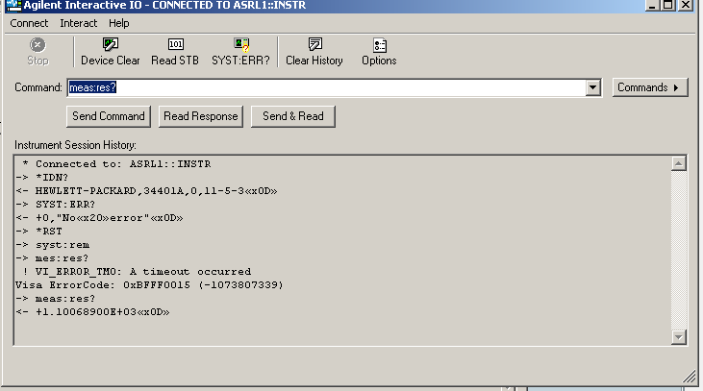

With the examples above it is indicated that the communication works well
In case a typing error occurs a time out appears

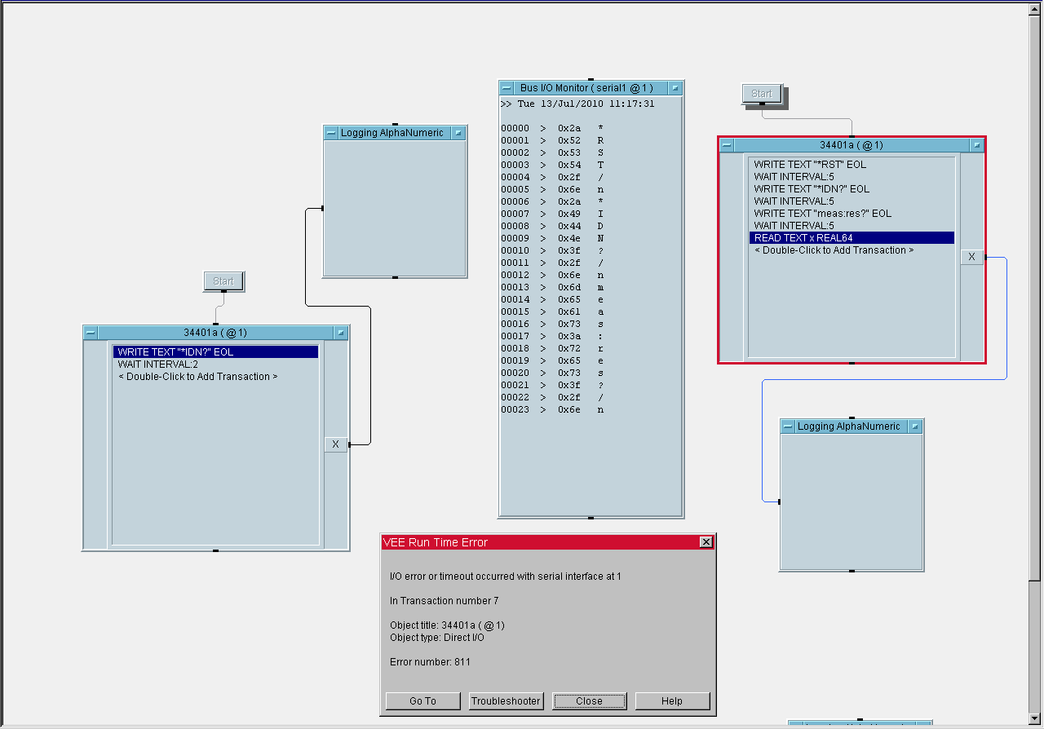

With VEE a error message has been generated: It is error 101: Invalid character. It is not understood why.

Below the RS-232 setting is sumarised.

Who can give support?

