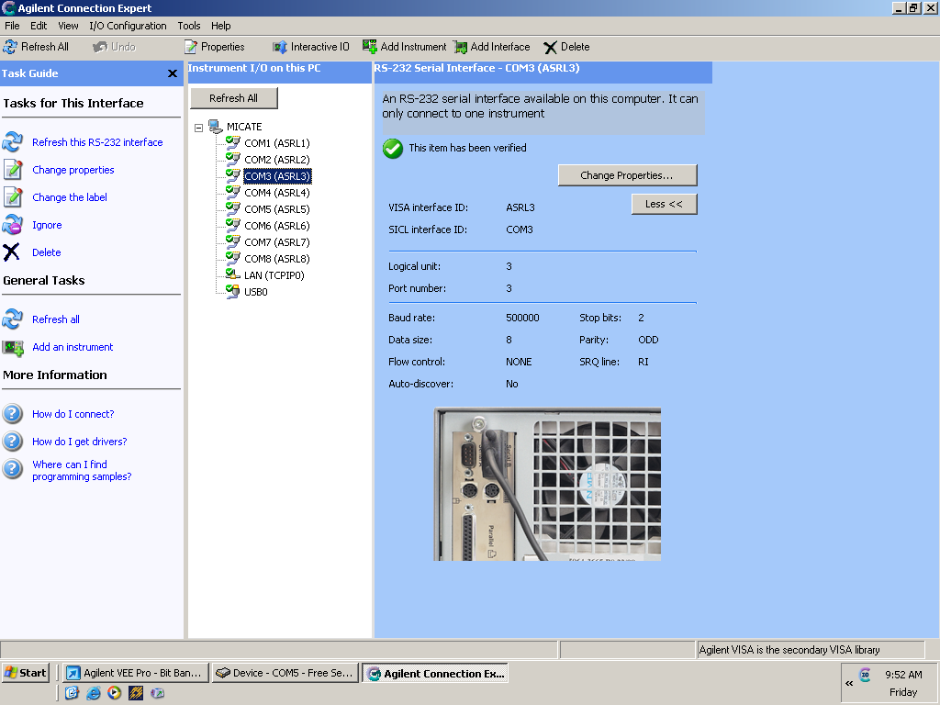
Com 3: RS-485 settings in Agilent Connection Expert
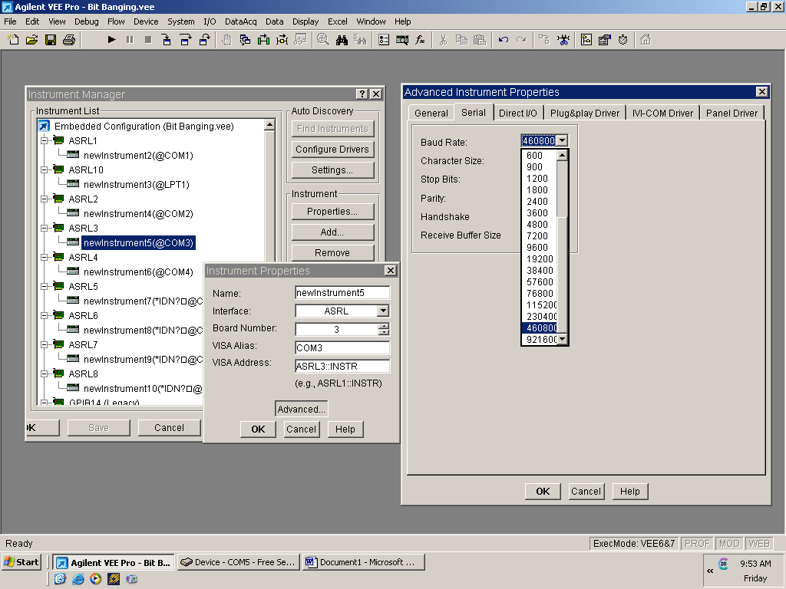
Com 3: RS-485 settings in Agilent VEE Pro 8 Instrument Manager
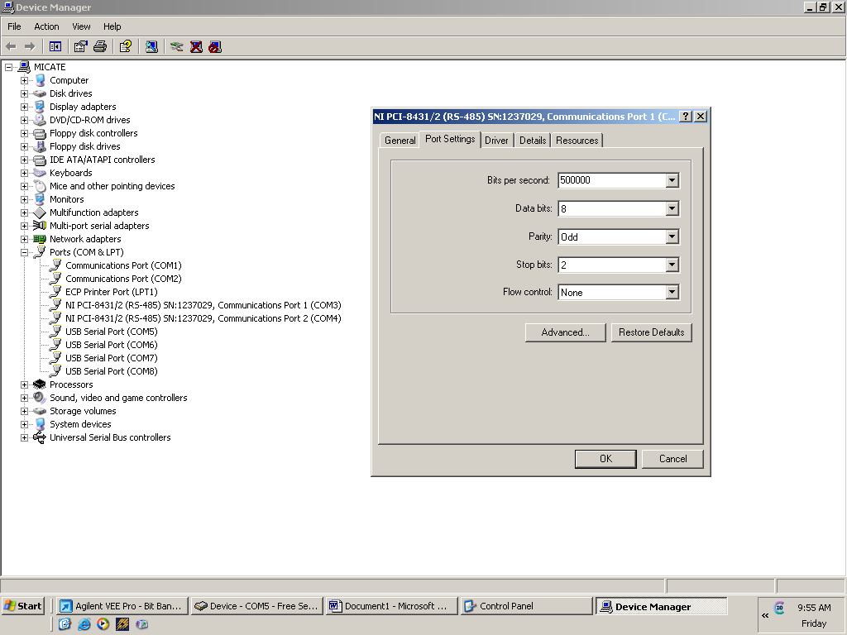
Com 3: RS-485 settings in Windows Device Manager

